**BASAVARAJESWARI GROUP OF INSTITUTIONS**

# Ballari Institute of Technology & Management

**AUTONOMOUS INSTITUTE UNDER VISVESVARAYA TECHNOLOGICAL UNIVERSITYJNANA SANGAMA, BELAGAVI 590018**

**INTERNSHIP**

**Report On**

**PLAYER PERFORMANCE ANALYSIS**

Submitted in partial fulfillment of the requirements for the award of degree of

# Bachelor of Engineering In

### COMPUTER SCIENCE AND ENGINEERING

**Submitted by**

**AISHWARYA.T**

**3BR22CS007**

### Internship Carried Out By

**EZ TRAININGS & TECHNOLOGIES PVT.LTD**

**HYDERABAD**

**Internal Guide External Guide**

**S.STEFFI NIVEDITA Bhavna Vaishnav**

**Asst.prof,CSE Technical Trainer**

**VARADA ALEKHYA**

**Asst. prof,CSE**

#### BALLARI INSTITUTE OF TECHNOLOGY & MANAGEMENT

NACC Accredited Institution*

**(Recognized by Govt. of Karnataka, approved by AICTE, New Delhi & Affiliated to Visvesvaraya Technological University, Belagavi)**

**"Jnana Gangotri" Campus, No.873/2, Ballari-Hospet Road, Allipur, Ballar1-583 104 (Karnataka) (India)**

**Ph: 08392 – 237100 / 237190, Fax: 08392 – 237197**

### 2023-2024

**BASAVARAJESWARI GROUP OF INSTITUTIONS**

### BALLARI INSTITUTE OF TECHNOLOGY & MANAGEMENT

**Autonomous institute under VISVESVARAYA TECHNOLOGICAL UNIVERSITYJNANA SANGAMA,**

**BELAGAVI 590018**

NACC Accredited Institution*

**(Recognized by Govt. of Karnataka, approved by AICTE, New Delhi & Affiliated to Visvesvaraya Technological University, Belagavi)**

**"JnanaGangotri"Campus,No.873/2,Ballari-HospetRoad,Allipur,**

**Ballar1-583 104 (Karnataka)(India)**

**Ph: 08392 – 237100 / 237190, Fax: 08392 –237197**

### DEPARTMENT OF COMPUTER SCIENCE AND ENGINEERING

**CERTIFICATE**

This is to certify that the Internship entitled **“ PLAYER PERFORMANCE ANALYSIS ”** has been successfully completed by **AISHWARYA.T** bearing USN **3BR22CS007** a bonafide student of Ballari Institute of Technology and Management, Ballari. For the partial fulfillment of the requirements for the **Bachelor’s Degree in Computer Science and Engineering** of the VISVESVARAYA TECHNOLOGICAL UNIVERSITY, Belagavi during the academic year 2023-2024.

#### Signature of Internship Co-ordinator

**Signature of HOD**

**S.STEFFI NIVEDITA R N KULKARNI**

**Asst.prof,CSE Prof. and HOD(CSE)**

**VARADA ALEKHYA**

**Asst. prof,CSE**

**DECLARATION**

I, **AISHWARYA.T ,** second year student of Computer Science and Engineering, Ballari Institute of Technology, Ballari, declare that Internship entitled **PLAYER PERFORMANCE ANALYSIS** is a part of Internship Training successfully carried out by **EZ TECHNOLOGIES & TRAININGS PVT.LTD**

**,Hyderabad** at “**BITM,BALLARI”.** This report is submitted in partial fulfillment of the requirements for the award of the degree, Bachelor of Engineering in Computer Science and Engineering of the Visvesvaraya Technological University, Belagavi.

**Date :03/05/2024 Signature of the Student**

**Place :BALLARI**

**ACKNOWLEDGEMENT**

The satisfactions that a company the successful completion of my internship on “ PLAYER PERFORMANCE ANALYSIS ” would be incomplete without the mention of people who made it possible, whose noble gesture, affection, guidance, encouragement and support crowned my efforts with success. It is my privilege to express my gratitude and respect to all those who inspired me in the completion of my internship.

I am grateful to our respective coordinator **“S**.**Steffi Nivedita (Asst.prof,CSE) , Varada Alekya (Asst.prof,CSE)”** for his noble gesture, support co-ordination and valuable suggestions givento me in the completion of Internship.

I also thank **R N Kulkarni,** H.O.D. Department of **Computer science and engineering** for extending all his valuable support and encouragement.

## Table of Contents

|  |  |  |
| --- | --- | --- |
| **Chapter No.** | **Chapter Name** | **Page No.** |
| **1** | **Company Profile** | **01** |
| **2** | **Day to day activity (student diary extract)** | **02** |
| **3** | **Abstract** | **03** |
| **4** | **Introduction of the project** | **04** |
| **5** | **Description** | **05** |
| **6** | **Algorithm** | **06-07** |
| **7** | **Output** | **08-10** |
| **8** | **Conclusion** | **11** |
| **9** | **References** | **12** |

**CHAPTER-1**

**COMPANY PROFILE**

**Company Name: EZ Trainings and Technologies Pvt. Ltd.**

**Introduction**:

EZ Trainings and Technologies Pvt. Ltd. is a dynamic and innovative organization dedicated to providing comprehensive training solutions and expert **development services. Established with a vision to bridge the gap between academic learning** and industry requirements, we specialize in college trainings for students, focusing on preparing them for successful placements. Additionally, we excel in undertaking development projects, leveraging cutting-edge technologies to bring ideas to life.

**Mission**:

Our mission is to empower the next generation of professionals by imparting relevant skills and knowledge through specialized training programs. We strive to be a catalyst in the career growth of students and contribute to the technological advancement of businesses through our development projects.

**Services:**

**College Trainings:**

• Tailored training programs designed to enhance the employability of students.

• Industry-aligned curriculum covering technical and soft skills.

• Placement assistance and career guidance.

Development Projects:

• End-to-end development services, from ideation to execution.

• Expertise in diverse technologies and frameworks.

• Custom solutions to meet specific business needs.

**Locations:** Hyderabad | Delhi NCR

At EZ Trainings and Technologies Pvt. Ltd., we believe in transforming potential into excellence

**DAY TO DAY ACTIVITIES:**

|  |  |  |
| --- | --- | --- |
| **Sl No** | **DATE** | Content covered |
| **01** | 28/04/24 | Project plan and setup |
| **02** | 29/04/24 | Code plan |
| **03** | 30/04/24 | Code plan, GUI implementation, implementing graphs |
| **04** | 02/05/24 | Project completion |

**CHAPTER-3**

**ABSTRACT:**

* This Streamlit application streamlines data management tasks by providing intuitive functionalities for CRUD operations (Create, Read, Update, Delete) on a DataFrame.
* Users can seamlessly input new data, modify existing records, or remove entries, fostering a dynamic and interactive data editing experience.
* Advanced features such as plotting enable users to visualize data distributions and relationships, facilitating deeper insights into the dataset.
* Error handling mechanisms are implemented to ensure robustness, guiding users through potential issues and maintaining application stability.
* The application's modular design allows for easy scalability and customization, accommodating future enhancements and additional features.
* Extensive documentation and user support resources are provided to assist users in effectively utilizing the application's capabilities.
* Continuous updates and improvements are planned based on user feedback, ensuring the application remains responsive to evolving user needs.
* Integration with cloud storage services and version control systems is considered for enhancing data accessibility and collaboration capabilities in future iterations.

**INTRODUCTION OF THE PROJECT**

**Chapter-4**

**Project Overview:**

This project introduces a user-friendly tool developed using Streamlit, designed to streamline data management tasks associated with Excel files.

The tool aims to simplify the process of adding, updating, deleting, displaying, and visualizing data, offering a seamless experience to users.

**Objective:**

The primary objective is to provide users with an intuitive web interface for managing Excel data efficiently.

By leveraging Streamlit's capabilities, the tool aims to enhance user productivity and ease of use in handling various data-related operations.

**Technology Used:**

The project harnesses the power of Python libraries such as Pandas, Matplotlib, Seaborn, and Streamlit, along with standard modules like datetime.

These technologies enable robust data manipulation, visualization, and web application development.

**Key Features:**

Users can effortlessly add new data, update existing records, delete entries, view data in a tabular format, and visualize trends through the intuitive interface.

The tool's functionalities cater to a wide range of data management needs, offering flexibility and convenience to users.

**User Interface:**

Streamlit's simplicity allows for rapid development of interactive web applications, ensuring a smooth and intuitive user experience.

**Error Handling:**

The tool incorporates effective error handling mechanisms to provide informative feedback to users in case of errors or invalid inputs.

**Conclusion:**

This Streamlit-based data management tool offers a practical solution for users seeking to efficiently manage Excel data.

**CHAPTER-5**

**Module description:**

**Streamlit DataFrame Manager Class:**

* Initialization: The class initializes by reading data from an Excel file and setting up the Streamlit application interface.
* Create Data: The create_data_in_dataframe() method allows users to input new data into the DataFrame and save changes to the Excel file.
* Update Data: The update_data_in_dataframe() method enables users to modify existing data in the DataFrame, ensuring data integrity and accuracy.
* Delete Data: Users can remove specific entries from the DataFrame using the delete_data_in_dataframe() method, maintaining data relevance.
* Display Data: The display_data() method presents the current DataFrame in the Streamlit app, facilitating data exploration and analysis.
* Plot Data: Users can visualize data trends and distributions through the plot_data() method, which offers options for countplot and line plot.

**Main Functionality:**

* Sidebar Navigation: The Streamlit app includes a sidebar with options for Create, Update, Delete, Display, and Plot actions, enhancing user interaction and navigation.
* User Input Handling: Various input fields and buttons are provided for users to input data, select options, and confirm actions, ensuring user-friendly interaction.
* Error Handling: The application incorporates error handling mechanisms to address issues such as file not found, parsing errors, and invalid user inputs, maintaining application stability.
* Date and Time Display: The app displays the current date and time to provide users with context and timestamp for their actions within the application.

**Execution:**

* Initialization: The code initializes by reading the DataFrame from an Excel file and setting up the Streamlit application interface.
* Action Selection: Users interact with the app by selecting actions from the sidebar menu, triggering corresponding functionalities for data manipulation and visualization.
* Continuous Execution: The Streamlit app runs continuously, allowing users to perform multiple actions sequentially until they choose to exit, ensuring a seamless and interactive experience.

**Overall Purpose:**

* Efficient Data Management: The module streamlines data management tasks by providing intuitive functionalities for CRUD operations on a DataFrame, enhancing productivity and analysis workflows.
* Interactive Data Exploration: Users can interactively explore and manipulate data, visualize trends, and gain insights through the Streamlit app, empowering data-driven decision-making processes.
* User-Friendly Interface: The application offers a user-friendly interface with responsive design principles, ensuring compatibility across devices and screen sizes, thus enhancing accessibility and user experience.

**CHAPTER-6**

**Algorithm**

1.start.

Execution begins.

2. Define Function to Save Changes:

Define a function save_changes(df, file_path) to save changes made to the DataFrame to an Excel file.

Try to write DataFrame to an Excel file using pd.ExcelWriter.

Handle exceptions like PermissionError and generic Exception.

3. Define Function to Create Data in DataFrame:

Define a function create_data_in_dataframe(df) to add new data to the DataFrame.

Prompt user to input new data for each column.

Upon button click, append the new data to the DataFrame and call save_changes() to save changes.

4. Define Function to Update Data in DataFrame:

Define a function update_data_in_dataframe(df) to update existing data in the DataFrame.

Prompt user to input column(s) and row index for update, along with the new value.

Update the DataFrame accordingly and call save_changes() to save changes.

5. Define Function to Delete Data in DataFrame:

Define a function delete_data_in_dataframe(df) to delete rows based on player name.

Prompt user to input the player name to delete.

Show matching rows and confirm deletion. If confirmed, delete rows and save changes.

6. Define Function to Display Data:

Define a function display_data(df) to display the DataFrame in the Streamlit app.

7. Define Function to Plot Data:

Define a function plot_data(df) to plot data from the DataFrame.

Provides options for countplot and line plot based on user selection.

Uses sns.countplot() for countplot and ax.plot() for line plot.

8. Define Function to Plot Line:

Define a helper function plot_line(df, x_column, y_column) to plot a line chart.

Used within plot_data() for line plot functionality.

9. Define Main Function:

Define a main() function to orchestrate the Streamlit app.

Reads the DataFrame from an Excel file.

Displays sidebar options for different actions: Create, Update, Delete, Display, and Plot.

Calls respective functions based on the user's selection.

Displays current date and time.

10. Main Execution:

Executes main() function if the script is run directly.

Execution finishes

**CHAPTER-7**

**OUTPUT:**

1. Upon running the Streamlit app, a sidebar titled "Choose action" is displayed with options: Create, Update, Delete, Display, Plot.

2. The user selects one of the options from the sidebar.

3. Depending on the selected option, the corresponding functionality is executed:

Create: User can input new data into the DataFrame. Upon clicking the "Add new data" button, the data is appended to the DataFrame and saved to an Excel file. The updated data is displayed.

Update: User can update existing data in the DataFrame. They are prompted to input the column(s) to update and the new value(s). The DataFrame is updated accordingly, and changes are saved to the Excel file. The updated data is displayed.

Delete: User can delete rows based on a player name. They input the player name to delete, and matching rows are displayed for confirmation. If the user confirms deletion, the rows are removed from the DataFrame and changes are saved to the Excel file. The updated data is displayed.

Display: The current state of the DataFrame is displayed.

Plot: User can select a plot type (Countplot or Line Plot) and columns for plotting. The corresponding plot is displayed based on the selected data.

4. The Streamlit app also displays a welcoming statement with the current date and time at the bottom.

5. The user can perform multiple actions sequentially by selecting different options from the sidebar. The application provides a user-friendly interface for data manipulation and visualization.

6. If the Excel file is not found or there is an error parsing the file, appropriate error messages are displayed to the user.

7. The application runs continuously until the user exits by closing the app or selecting the "Exit" option.

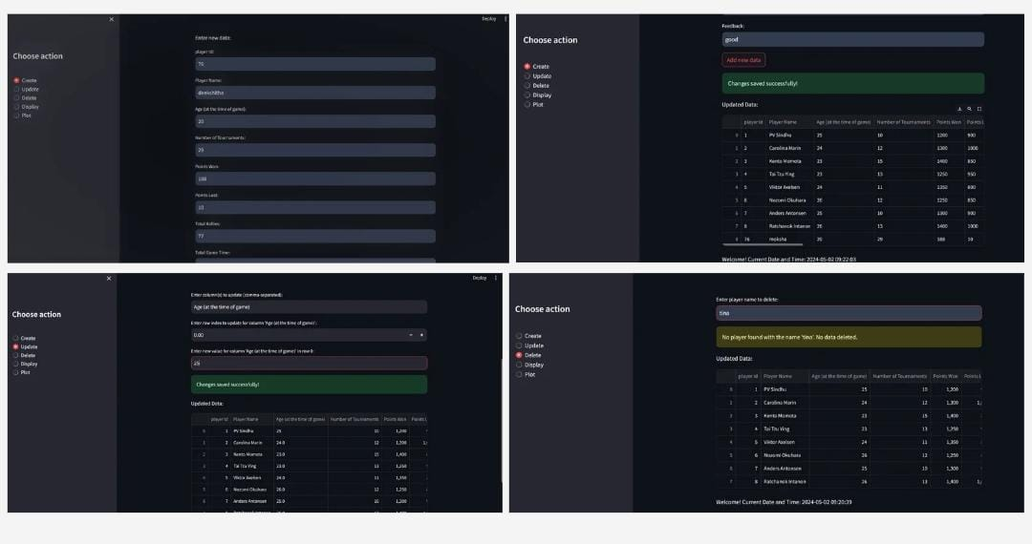

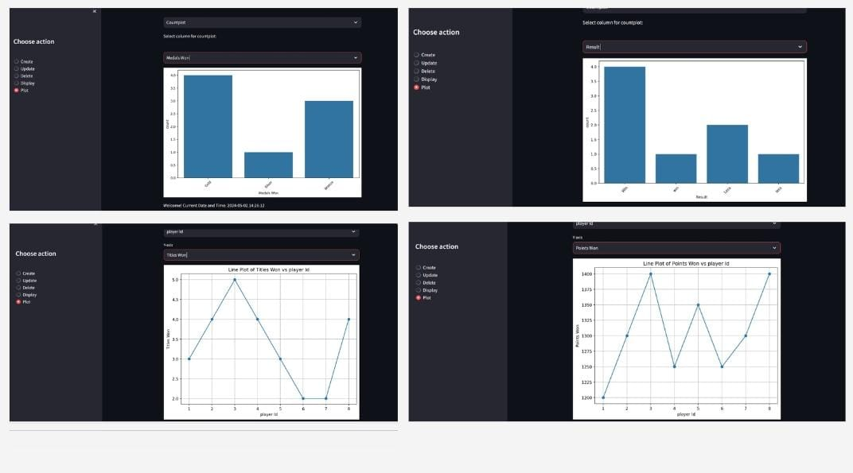

**CHAPTER-8**

**Conclusion:**

**.**Overall, this project serves as a valuable tool for sports professionals, analysts for enhancing performance & achieving competitive advantage.

.This project covers data managing, manipulating, visualising, error handling, continuous improvement, scalability & versatality of players performance.

**CHAPTER-9**

**REFERENCE:**

**\***google

*class notebook

*python documentation